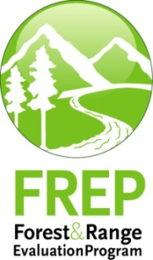
Multiple Resource Value Assessment (MRVA)
Bulkley Timber Supply Area
Skeena Stikine Natural Resource District
December 2013

Foreword
Forest management in British Columbia is governed by a hierarchy of legislation, plans and resource management objectives. For example, federal and provincial acts and regulations, Land Use and Forest Stewardship plans, and protected areas and reserves collectively contribute to achieving balanced environmental, social and economic objectives. Sustainable forest management is key to achieving this balance and a central component of forest management certification programs. The purpose of the Multiple Resource Value Assessment (MRVA) report is to provide resource professionals and decision makers with information about the environmental component of this ‘balance’ so that they can assess the consistency of actual outcomes with their expectations.

The Forest and Range Practices Act (FRPA) lists 11 resource values essential to sustainable forest management in the province; biodiversity, cultural heritage, fish/riparian and watershed, forage and associated plant communities, recreation, resource features, soils, timber, visual quality, water, and wildlife. The MRVA report is a summary of the available field-based assessments of the conditions of these values. Field assessments are generally conducted on or near recently harvested cut blocks and therefore are only evaluating the impact of industrial activity and not the condition of the value overall (e.g. they don’t take into account protected areas and reserves). Most of the information is focused on the ecological state of the values and provides useful information to resource managers and professionals on the outcomes of their plans and practices. This information is also valuable for communicating resource management outcomes to stakeholders, First Nations and the public, and as a foundation for refining government’s expectations for sustainable resource management in specific areas of the province.

I encourage readers to review the full report and direct any questions or comments to the appropriate district office.

(ADMs electronic signature here)

Tom Ethier
Assistant Deputy Minister
Resource Stewardship Division
Ministry of Forests, Lands and Natural Resource Operations

Multiple Resource Value Assessments—In Brief
Multiple resource value assessments show the results of stand and landscape-level monitoring carried out under the Forest and Range Evaluation Program (FREP). This report summarizes results for riparian, biodiversity (stand level), water quality (sediment), cultural heritage and timber (stand-development) monitoring conducted in the Bulkley Timber Supply Area and includes a district manager commentary of key strengths and weaknesses. Through MRVA reports, decision makers communicate expectations for sustainable resource management of public resources and identify opportunities for continued improvement.
Figure 1: Bulkley Timber Supply Area site-level resource development impact rating by resource value with trend (Riparian, stand-level biodiversity by harvest year/era. Water quality and cultural heritage by evaluation year. Timber samples are all post-free growing.)
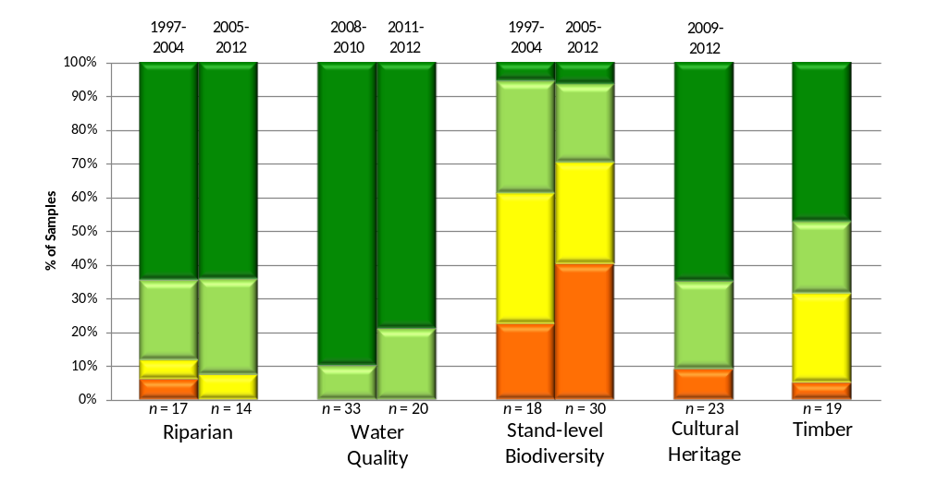

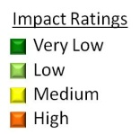

Important Context for Understanding this Assessment
The extraction and development of natural resources, along with natural factors (e.g., insects, wind, floods), influence and impact ecological condition. The goal of effectiveness evaluations is to assess these impacts on the state of public natural resource values (status, trends, and causal factors); such evaluations do not assess compliance with legal requirements. These evaluations help resource managers:
- assess whether the impacts of resource development result in sustainable resource management
- provide transparency and accountability for the management of public resources
- support the decision-making balance between environmental, social, and economic factors
- inform the ongoing improvement of resource management practices, policies, and legislation.
The resource development impact ratings contained in this report are based on assessments conducted within the areas where resource extraction takes place and do not reflect the ecological contributions of parks, protected areas, or other conservancy areas.
Although this report focuses on forestry-related activities, FREP monitoring protocols have also been applied to other resource sector activities, including mining (roads) and linear developments (hydro and pipelines). Procedures are being adapted to expand monitoring into these resource sectors over time.

Introduction
The development of the Forest and Range Practices Act (FRPA) had several key objectives, including:
- simplifying the forest management legal framework
- reducing operational costs to both industry and government
- allowing “freedom to manage”
- maintaining the high environmental standards of the Forest Practices Code of British Columbia Act (FPC).
As part of the results-based FRPA framework, the provincial government committed to conducting effectiveness evaluations and publically reporting the monitoring results. The science-based information provided by these evaluations will be used to determine whether FRPA is achieving the government’s objectives of maintaining high environmental standards and ensuring sustainable management of public resources. If those objectives are not being met the monitoring results will be used to help inform the necessary adjustments to practices, policies, and legislation. Government is delivering its effectiveness evaluation commitment through the Forest and Range Evaluation Program (FREP; for details, see http://www.for.gov.bc.ca/hfp/frep/). The 11 FRPA resource values monitored under FREP include: biodiversity, cultural heritage, fish/ riparian & watershed, forage and associated plant communities, recreation, resource features, soils, timber, visual quality, water and wildlife.
Multiple Resource Value Assessments (MRVAs) reflect the results of stand- and landscape-level monitoring carried out under FREP. The program’s stand-level monitoring is generally conducted on forestry cutblocks, resource roads, or other areas of industrial activity. As such, these evaluations provide a stewardship assessment of resource development practices. Landscape-level monitoring of biodiversity, visual quality, and wildlife resource values is more broadly an assessment of the overall landscape. Reports on MRVAs are designed to inform decision making related to on-the-ground management practices, statutory decision-maker approvals, and data for the assessment of cumulative effects.
This report summarizes FREP monitoring results for the Bulkley Timber Supply Area. MRVA reports clarify resource stewardship expectations, and promote the open and transparent discussion needed to achieve short- and long-term sustainable resource management in British Columbia.
MRVA reports are intended for those interested in the status and trends of resource values at the timber supply area (TSA) or natural resource district scale, such as natural resource managers and professionals, government decision makers, and First Nations. These reports are also useful in communicating resource management outcomes to the public.
Government managers and decision makers are encouraged to consider this information when:
- discussing district or TSA-level resource stewardship with staff, licenced stakeholders, tenure holders and First Nations
- clarifying expectations for sustainable resource management of public land
- integrating social and economic considerations into balanced decision making
- reviewing and approving forest stewardship plans
- developing silviculture strategies for TSAs
- assessing Timber Supply Reviews and their supporting rationale
- informing decision making at multiple scales.
Natural resource professionals are encouraged to consider this information, along with other FREP information such as reports, extension notes, protocols, and monitoring data to:
- maintain current knowledge of the resources they manage
- inform professional recommendations and decisions, particularly when balancing of environmental, social, and economic values
- enhance resource management, consultation, and treaty rights discussions between First Nations, government, and licensees.
Published FREP reports and extension notes contain detailed findings for each resource value. These documents are available on the FREP website at: http://www.for.gov.bc.ca/hfp/frep/publications/reports.htm. Licensees can request data collected on their operating areas. FREP staff will assist licensees with the analysis of their data and the preparation of licensee-specific MRVA reports.
Although this MRVA report documents monitoring results at the district or TSA level, the MRVA concept is scalable. Reports for individual licensees, treaty settlement areas, or landscape units can be produced when sufficient monitoring data is available. Reports can also be prepared at the regional or provincial levels. This report provides site-level resource value assessments and trends through comparisons of cutblocks harvested before 2005 with those harvested in 2005 or later (where data is sufficient). FREP’s site assessment monitoring results on each resource value are categorized by impact (very low, low, medium, or high). This classification reflects how well site-level practices achieve government’s overall goal of sustainable resource management. Site-level practices that result in “very low” or “low” impact are consistent with sustainable management objectives. Practices resulting in “high” impact are seen as inconsistent with government’s sustainability objectives. For a description of the MRVA methodology see Appendix 1.

Bulkley Timber Supply Area – Environmental and Stewardship Context
The 763 000 hectare Bulkley TSA is administered by the Ministry of Forests, Lands and Natural Resource Operation’s Skeena Stikine Natural Resources District. Smithers is home to both the District and Skeena Region offices. The population of approximately 11 000 people resides in Smithers, Telkwa, First Nations communities of Moricetown and Ft. Babine, and surrounding rural areas.
First Nations with traditional territories in Bulkley TSA include Wet’suwet’en (Office of Wet’suwet’en, Moricetown Band, and Wet’suwet’en First Nation), Gitxsan, Lake Babine, and Kitselas. Cultural heritage features are diverse and relatively abundant, and include seasonal and permanent village sites; major trade and territorial access trail networks; and associated cache pits and culturally modified trees.
The forestry sector dominates the local economy. Smithers-based Pacific Inland Resources Division (PIR) lumber mill and operations are the western most consistently operating primary processing facility in BC’s northwest interior.
Bulkley’s annual allowable cut (AAC) is presently set at 852 000 m³/year based on a ~300 000 hectare Timber Harvesting Land Base (THLB). Because the TSA has a significant profile of marginal sawlog and pulp fibre in mature stands, 41 percent of the AAC is partitioned to those types. From 2001 to 2007, several Bulkley licenses were transferred to Morice and Prince George TSAs and Bulkley harvested volumes averaged less than 40 percent of the AAC. These licenses were transferred back in 2008 and harvest volumes have since ramped up to near-AAC levels.
Bulkley TSA transitions coastal and interior climates and is ecologically diverse. Sub-Boreal Spruce (SBSmc2, dk) and Engelmann Spruce-Subalpine Fir (ESSFmc, wv) biogeoclimatic zones dominate. Small areas of Interior Cedar-Hemlock (ICHmc2), Coastal Western Hemlock (CWHws2), and Mountain Hemlock (MHmm) biogeoclimatic zones also present. Dominant tree species (as percent of timber harvesting landbase) are subalpine fir (48 percent), lodgepole pine (25 percent), spruce (23 percent), and western and mountain hemlock (4 percent).
Bulkley TSA is at the northwest extent of the recent mountain pine beetle epidemic. Although mature pine comprises about 25 percent of TSA forests, as of 2012 the Bulkley timber supply forecast remains stable with only a minor predicted mid-term drop. This is attributable to a rapid shift of major licensee operations into a continuing salvage harvest effort with prompt reforestation, a collapse in the MPB epidemic, and to the contribution of non-pine mature volumes and secondary structure to future timber supply. Other forest health issues are present but remain at minor or endemic levels.
The shift of harvest focus to beetle-impacted pine has had implications to harvest profile, average cutblock size and timber access strategy. Harvest in the marginal sawlog/pulp AAC partition has reduced, the proportion of small (less than 15 hectare) cutblocks has increased significantly; and there is increased reliance on temporary and winter roads versus construction of new permanent roads.
Bulkley has a tradition of strategic planning that started in the early 1980’s and culminated in the 1998 Bulkley Land Resource Management Plan (LRMP). Legal objectives were established in 2000 and 2006 for:
- landscape-level biodiversity (core ecosystems; landscape corridors; tree species diversity; early, mature, and old seral stage distribution)
- stand-level biodiversity (wildlife tree patch retention)
- wildlife habitat management and access control (for grizzly bear, mountain goat, moose, woodland caribou, deer)
- timber
- recreation (opportunities and access)
- visual quality (established VQO’s and viewpoints)
- Special Management Zones (SMZ1 - no harvest, SMZ2 – harvest permitted with focus on managing non-timber values).
Babine Lake is along the eastern TSA boundary. Bulkley, Telkwa and Babine Rivers are present in the TSA, and contribute significantly to management of Skeena River fish populations. Five Fisheries Sensitive Watersheds with legal objectives are approved for tributaries of these major rivers.
There is strong commitment, by local government staff at District and Regional levels, by forest industry, and public to the Bulkley LRMP implementation, ongoing effectiveness monitoring, and continuous improvement (CI). Within the Bulkley TSA, FREP serves as one of a number of monitoring initiatives for objectives set by government: other forms of monitoring have also been undertaken by government agencies, licensees, and by various Smithers-based volunteer and charitable organizations.
Locally, the Skeena Region has initiated development of a “Skeena Integrated Monitoring Framework” intended to incorporate best elements of multiple monitoring initiatives, including FREP, the Skeena Cumulative Effects demonstration pilot, and, potentially, the initiatives mentioned above.

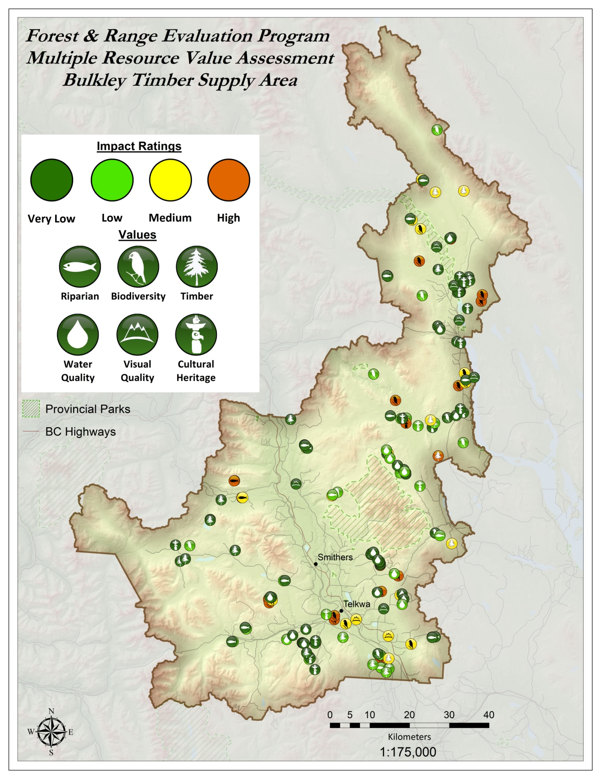
Figure 2: Bulkley Timber Supply Area, showing FREP sample locations and results (see http://www.for.gov.bc.ca/hfp/frep/publications/mrva.htm for a high-resolution version of this map).

Key Results by Resource Value and Opportunities for continued improvement
Table 1 shows the resource values assessed for the Bulkley Timber Supply Area, and includes a summary of key findings, causal factors, trends, and opportunities for continued improvement. Data are presented for FPC-era samples at sites harvested before 2005 and FRPA-era samples at sites harvested in 2005 or later. This approximates the Forest and Range Practices Act (FRPA) era, and allows for a comparison between earlier and later stewardship practices. The impact rating indicates the effect of resource development on the resource value, from “very low” to “high” impact.
Table 1: Resource development impact rating, key findings, and opportunities for improvement by resource value for the Bulkley Timber Supply Area.
Riparian: Resource Development Impacts on Stream Function
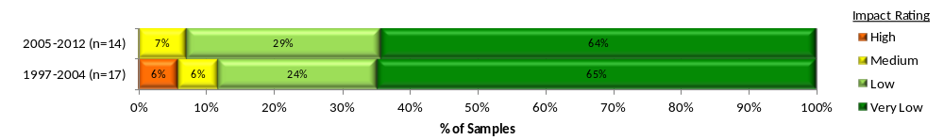
Summary:  Of the 31 streams monitored (combined FPC and FRPA eras), 90% were rated as “very low” or “low” harvest-related impacts: 65% of streams are Properly Functioning (“very low” impact), 26% are Properly Functioning with limited impact (“low” impact), 6% are Properly Functioning with impact (“medium” impact) and 3% are Not Properly Functioning (“high” impact).  Causal Factors:  There were only three streams in the “high” or “medium” impact classification. The single “high” impact rated stream segment was an in-block S6 class stream with no trees in the Riparian Management Area and very little understory retention. Stream issues were channel bed disturbance and fine sediment introduction. Of the 28 “low” and “very low” impacted streams, 79% of them had 10 m or more of treed riparian buffer, with the remaining 21% having some level of treed buffer and an average of 73% full understory buffer in the first 10 m.  Number of Samples by Stream Class and Impact Rating: | Overall Stewardship Trend: Neutral  With low sample size, this trend is an indication only and might change with an increase in samples. There appears to be little change in the data categories between FPC- and FRPA-eras.  Opportunities For Continued Improvement:  Fine sediment management is a consideration in this TSA. Windthrow is a contributor to this sediment in 6 of 11 of the streams in the bottom three categories.
  Class | High | Medium | Low | Very low | Total
  S3 |  | 2 |  | 6 | 8
  S4 |  |  | 3 | 1 | 4
  S5 |  |  |  | 3 | 3
  S6 | 1 |  | 5 | 10 | 16
  Total | 1 | 2 | 8 | 20 | 31

Water Quality (fine sediment): Resource Development Impacts on Water Quality
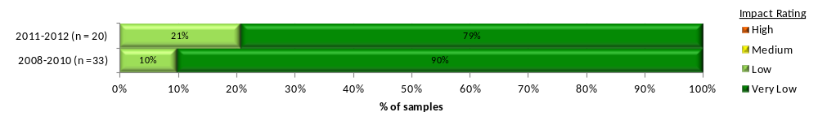
Summary:  Of the 53 road segments assessed from 2008 to 2012, 10% were rated as “very low” or “low” road-related impact.  Site assessments show the range for potential sediment generation as 83% “very low” (“very low” impact), 17% “low” (“low” impact) and no “moderate” (“medium” impact), “high,” or “very high” (“high” impact) road segments.  Causal Factors:  Road management that resulted in “very low” impact ratings made use of roadside vegetation, kick outs and sediment ponds. | Overall Stewardship Trend: neutral  There is a slight increase in “low” compared to “very low” impacted road segments in later years, however, with all road segments rated as “low” or “very low” impact, this is not a concern.  Opportunities For Improvement:  Looks good

Stand-level Biodiversity: Resource Development Impacts on Stand-Level Biodiversity
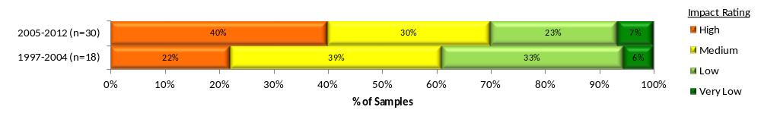
Summary:  Of 48 cutblocks sampled (combined FPC and FRPA-eras), 33% of sites were rated as “very low” or “low” harvest-related impact.  Considering total retention, retention quality, and coarse woody debris quantity and quality, 6% sites are rated as “very low” impact on biodiversity, 27% as “low,” 33% as “medium,” and 33% as “high.”  Causal Factors:  Coarse woody debris volume increased slightly from FPC- era to FRPA-era, as did coarse woody debris quality. However, in particular for the big pieces of coarse woody debris (≥20 cm dbh and ≥10 m long), the range of data is still skewed to the bottom half of the natural variation as found within retention patches. 82% of all blocks had more than 3.5% tree retention. Retention decreased from an average 23.4% in the FPC-era to 11.7% in the FRPA-era. Retention quality has decreased, although both of these trends are tied to the shift to harvest smaller MPB salvage cutblocks. | Overall Stewardship Trend: Decreasing  This is due to a decrease in percentage of tree retention and a decrease in retention quality.  Opportunities For Continued Improvement:  A large improvement will come from leaving >3.5% retention on every cutblock. During the FPC-era there were 10% of blocks with <3.5% retention and this increased to 23% in the FRPA-era. Continue trend of better quality coarse woody debris (i.e., big pieces). Increase retention quality by retaining large snags (≥30 cm dbh and ≥10 m height), large trees (e.g. ≥40 dbh) in densities similar to pre-harvest conditions. Leave the full range of tree species available. . It is expected that many of these opportunities will be realized through the transition of harvest back from MPB salvage to the harvest of green timber.

Visual Quality: Resource Development Impacts on Achievement of Visual Quality Objectives

There are currently only 8 Visual Quality samples in the Bulkley TSA. Analysis will be completed in subsequent years when more samples are available.
Cultural Heritage: Resource Development Impacts on Cultural Heritage Resources
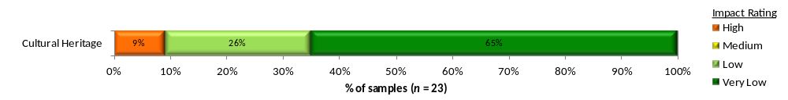
Summary:  Of the 23 cutblocks assessed, 91% were rated “very low” or “low” harvest related impact.  70% of blocks were considered “well” (“low” impact) to “very well” (“very low” impact) managed, 22% “moderately” (“medium” impact) and 9% were “poorly” (“high” impact) managed.  At the feature level, 95% show no evidence of harvest-related damage while 5% showed evidence of damage. None of the damaged features had irreversible damage and/or were rendered unsuitable for continued use.  Causal Factors:  The primary cause of damage was road building. | Overall Stewardship Trend: Insufficient Data  There was no FPC-era sampling; therefore, no FPC/FRPA-era trends are available. Future trend analysis will use year of assessment.  Opportunities for Continued Improvement:  Continue careful consideration of cultural heritage resource values in the planning phase. Continue discussions between licensees and First Nations to enhance understanding of perspectives ensure existing cultural heritage resource information is shared and increase the potential for effectively identifying on-site cultural heritage resource values. Put cultural heritage resource features on site plans and logging plans. Communication of management actions (verbally and with maps) to operators before harvesting begins.

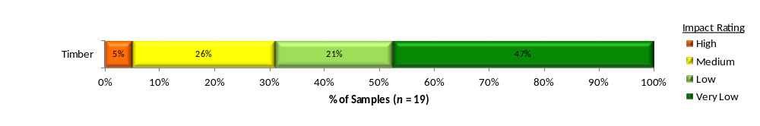
Timber Resource Value: Resource development impacts on the overall health and stocking of managed 20-40 year stands
Summary:  Of the 19 polygons sampled in 2011 and 2012 the weighted average well spaced density over the three biogeoclimatic ecosystem classification (BEC) zones achieved 86% of target stocking standard (TSS).  Percent of stocking standard by BEC  68% of the polygons were rated “very low” and “low” impact to health and stocking; 26% “medium”, and 5% “high”. It was uncertain from the data whether some of the “medium” or “high” impact rated polygons were spaced. A draft Bulkley TSA – Stand Development Monitoring Data Summary Report (only 9 polygons from 2011) reported the total stems/ha (for all BECs) was 2725 stems/ha and 1068 stems/ha for well-spaced trees. No change in leading species (between declaration and stand development monitoring) was found in 7 (78%) of the 9 polygons sampled. The four leading stand damaging agents were: snow press (NY), Warren’s root collar weevil (IWW), Western gall rust (DSG), and moose browse (AM). | Causal Factors:  The ratings of two polygons, one rated “low” impact, the other “high” impact were a result of vegetative competition and western gall rust causing the well spaced values to be close to the minimum stocking standard (720 and 820 stems/ha, respectively). An additional “high” impact rated polygon was the result of significant logging (TL) damage. Moose damage was the causal factor in another “medium” impact rated polygon. There were gaps in the data from the free-growing declaration with regards to total and well spaced stems/ha. For this reason, it was not known if one each of the “medium” and “high” impacted rated polygons were a result of low stocking at free growing.  Overall Stewardship Trend:  No trend can be established at this time.  Opportunities for Continued Improvement:  An updated Bulkley TSA – Stand Development Monitoring Data summary will be able to provide more detailed information for this TSA.  NOTE: Completing the Stand Development Monitoring. Polygon Coversheets will provide a clearer picture why some stands have such low stocking
  BEC | ESSF | SBS | ICH | AVG
  TSS | 91% | 82% | 98% | 86%
  Agent | NY | IWW | DSG | AM
  90 plots | 36/90 | 25/90 | 24/90 | 12/90
Landscape-level Biodiversity: Is the forested matrix at the landscape-level providing the range of habitat understood as necessary for maintaining ecosystem function and old and mature forest dependant species?
In development. The three primary landscape-level biodiversity indicators are: (1) site index by leading species (ecosystem representativeness); (2) percent of TSA by age class (young, mid-, mature, and old forest); and (3) percent interior habitat of old forest. Each indicator is categorized by percent in non-commercial land base, timber harvesting land base, and protected areas. Data for these indicators is derived from Hectares BC and other spatial databases.

Resource Value Stewardship Results Comparison
Tables 2 provides ratings of stewardship effectiveness at varying scales. Effectiveness is determined by the percentage of samples with a “very low” or “low” resource development impact rating. Appendix 2 shows results by resource value for the North, South and Coast Areas and the province as a whole.
Table 2: Stewardship effectiveness within the Skeena Region as determined by resource development impact rating (ID = Insufficient Data; sample sizes in brackets).
Resource Value | Effectiveness of Practices in Achieving Resource Stewardship Objectives:  % Very low + Low Resource Development Impact Rating (sample size in brackets)
Resource Value | Skeena Region TSA Comparison |  |  |  |  |  |  | Skeena Regionª
Resource Value | Bulkley | Lakes | Morice | Kispiox | Nass | Kalum | North Coast | Skeena Regionª
Riparian – all data  FRPA-era data  FPC-era data | 90% (31)  93% (14)  88% (17) | 64% (36)  68% (19)  59% (17) | 74% (42)  83% (18)  67% (24) | 85% (27)  ID (9)  83% (18) | ID (9) | 75% (53)  73% (15)  81% (36) | 76% (45)  76% (21)  75% (24) | 77% (243)  80% (100)  75% (141)
Water quality – all data  2010–2012 samples  2008–2009 samples | 100%²(53)  100% (46)  ID (7) | 52% (83)  ID (35)  48% (48) | 46% (92)  ID (46)  43% (46) | 93% (58)  ID (32)  ID (26) | ID (15) | 84%^{b}(119)  83% (103)  ID (16) | ID (45) | 73% (465)  79% (291)  63% (174)
Stand-level biodiversity all data  FRPA-era data  FPC-era data | 33% (48)  30% (30)  39% (18) | 28% (46)  17% (23)  26% (23) | 38% (29)  50% (14)  27% (15) | 76% (37)  83% (18)  68% (19) | 36%(11) | 52% (46)  87% (15)  35% (31) | 74% (43)  95% (20)  57% (23) | 48% (260)  55% (121)  42% (139)
Cultural Heritage | 91%  (23) | 81%  (21) | 84%  (13) | ID  (6) | ID  (0) | ID  (6) | ID  (6) | 82%  (75)
ª Nadina, Coast Mountains and Skeena-Stikine Natural Resource Districts
^{b} Note that a different split of data was used in table 1 for Bulkley to allow for sufficient data in each date range (there were few data points in 2008 or 2009 for water quality data). For comparisons between districts however, a consistent date range must be used.

District Manager Commentary

The monitoring results in this assessment provide our current understanding of the state of resource values being sampled in the Bulkley TSA. Conclusions on outcomes and trends can be drawn from analysis of this data and are included in the assessment. With this commentary I will attempt to provide additional perspective to the interpretation of the results and to suggest areas of focus for improved resource management.

Trends and Concerns:

Stand-level biodiversity monitoring results show the biggest challenge for the resource values sampled. Stand level biodiversity is an important contributor to our overall landscape-level biodiversity management and is strongly connected with many other values such as wildlife habitat. Recent monitoring results reflect a trend that has progressed in the wrong direction and a decrease in coarse woody debris (CWD) quality and in stand-level retention. Interpretation of these results has to take into account the positive effort that has been undertaken by Forest Licensees at mountain pine beetle (MPB) suppression and salvage. Due to these ongoing MPB suppression activities in the Bulkley TSA, small salvage blocks have been primarily used to address MPB infestations resulting in proportionately less tree retention and quality (while still meeting the approved land use planning retention targets). The trend for leaving more tree retention and quality should increase as forest licensee’s move to larger block sizes with increased tree retention and quality in the future.

Areas of Focus:
A “high” impact rating does not meet the government’s overall objective of sustainable resource management and should be avoided. Similarly, “medium” impact practices should be minimized to reduce risks. With that in mind, I expect forest practitioners to:
- increase both the quantity and quality of stand-level retention associated with harvest areas
- place a greater emphasis on stand development monitoring to inform silvicultural strategies
- continue to consider cultural heritage resources during the planning phase

I will be discussing these results further with timber licensees in the TSA and in some cases will be looking for increased detail in Forest Stewardship Plans.

Riparian monitoring results will continue to be evaluated as the sample size increases through future sampling. Forest practitioners are encouraged to continue implementing good road management and sediment control measures.

Future Opportunities:

I will be seeking additional data before further interpretation of the timber monitoring results. Of increasing importance in our management of this resource is to build resilience into managed stands for climatic variation and forest health. I will continue to evaluate stocking standards as FSPs are replaced or extended and as improved information becomes available. I will also encourage the development of more detailed silviculture strategies along with a district forest health strategy to assist in guiding planning and practices in these areas.

I also expect to see the development of additional monitoring protocols aimed at better understanding of our performance in managing for landscape-level biodiversity, fish and wildlife and that sampling is carried out for activities associated with the full range of natural resource development activities.

Appendix 1: Summary description of resource development impact rating criteria
Table A1.1 shows the criteria used to determine the resource development impact ratings for each resource value. Detailed rating criteria, methodology, and definition of terms used are described in the companion document FREP Technical Note #6: Methodologies for Converting FREP Monitoring Results to Multiple Resource Value Assessment (MRVA) Resource Development Impact Ratings (http://www.for.gov.bc.ca/ftp/HFP/external/!publish/frep/technical/FREP_Technical_Note_06.pdf). The ratings of “very low”, “low”, “medium” and “high” are “technical ratings” based on best available science.
Table A1.1: Criteria for determining resource development impact rating outcomes for each resource value.
Resource Value | FREP Evaluation Question | Indicators | Resource Development Impact Rating Criteria | Very low | Low | Medium | High
Riparian | Are riparian forestry and range practices effective in maintaining the proper functioning of riparian areas? | Fifteen key questions (e.g., intact channel banks, fine sediments, riparian vegetation) | Number of “no” answers on assessment questions of channel and riparian conditions | 0–2 | 3–4 | 5–6 | > 6
Stand-level  Biodiversity | Is stand-level retention providing the range of habitat and attributes understood as necessary for maintaining species dependant on wildlife trees and coarse woody debris? | Percent retention, retention quality from nine key attributes (e.g., big patches, density of large diameter trees), coarse woody debris volume, coarse woody debris quality from two key attributes (e.g., density of pieces ≥ 10 m and 20 cm, and volume of large diameter pieces | Cumulative score. A 60/40 weighting is used for tree retention versus coarse woody debris, recognizing the longer-term ecological value of standing retention. | > 70% | 55–70% | 40–55% | < 40%
Water Quality (sediment) | Are forest practices effective in protecting water quality? | Fine sediment potential | Fine sediment (m³) due to expected surface erosion or past mass wasting | < 0.1 | < 1 | 1–5 | > 5
Soils | Are forest practices preventing site disturbance that is detrimental to soil productivity and hydrologic function? | Amount of access, restoration of natural drainage patterns, road side work area soil disturbance, amount of mature forest and coarse woody debris and restoration of natural drainage patterns | Overall assessment of practices on cutblock to maintain soil productivity and hydrologic function | Well | Moderately |  | Poor
Cultural Heritage | Are cultural heritage resources being conserved and where necessary protected for First Nations cultural and traditional activities? | Evidence and extent of damage to features, operational limitations, management strategies and type and extent of features | Combined overall cutblock assessment results with consideration of individual feature assessment results | See methodology report
Timber: Stand Development Monitoring | What is the overall health and productivity of managed 20-40 year stands? | Impacts of forest health factors on stand stocking (ratio of total and well spaced) | Forest health damaging agent (% level of incidence) and level of stocking (well spaced stems per hectare) | ≥ 1.7 | 0.8–1.69 | 0.3–0.79 | 0–0.29
Landscape-level  Biodiversity | Is the forested matrix at the landscape-level providing the range of habitat understood as necessary for maintaining ecosystem function and old and mature forest dependant species? | Ecosystem representativeness, age class and interior old | Overall ranking: within protected and non-protected areas | Ranking under development
Visual Quality | How are we managing views in scenic areas and achieving visual quality objectives? | Visual evaluation of block, design of block, percent of landform altered, impact of roads, tree retention and view point importance | Basic visual quality class (determined using the VQC definitions) is compared with the Adjusted VQC (derived using percent alteration measurements and adjustment factors) to determine if VQO is achieved. | VQO achieved, and % alteration low or mid-range | VQO achieved, but % alteration for one or both close to alteration limit | Only one method indicates VQO achieved | Both methods indicate VQO not achieved

Appendix 2: Comparative FREP Results by Resource Value for other AREAS
Table 2 describes overall ratings for the Bulkley Timber Supply Area as compared to adjacent TSAs or districts. The table below describes the same results but by the North, South and Coast areas and the province as a whole. The three operational areas represent combined natural resource regions.
Table A2.1: FREP monitoring results by resource value for the North, South, and Coast Areas and the province as a whole compared to the Bulkley Timber Supply Area.
Resource Value | Effectiveness of Practices in Achieving Resource Stewardship Objectives:  % Very low + low resource development impact rating (sample size in brackets)
Resource Value | Bulkley  TSA | Forests, Lands and Natural Resource Operations Areas |  |  | Province
Resource Value | Bulkley  TSA | North | South | Coast | Province
Riparian – all data  FRPA-era data  FPC-era data | 90% (31)  93% (14)  88% (17) | 71% (654)  71% (257)  71% (394) | 69% (678)  68% (277)  70% (401) | 58% (451)  62% (198)  55% (253) | 67% (1783)  67% (732)  67% (1048)
Water quality – all data  2010–2012 samples  2008–2009 samples | 100% (53)  100% (46)  ID (7) | 66% (992)  67% (505)  64% (487) | 70% (1515)  70% (823)  70% (692) | 76% (1526)  79% (1021)  70% (505) | 71% (4033)  73%(2349)  68% (1684)
Stand-level biodiversity –all data  FRPA-era data  FPC-era data | 33% (48)  30% (30)  39% (18) | 42% (655)  49% (270)  38% (385) | 54% (780)  61% (347)  49% (433) | 77% (455)  84% (201)  72% (254) | 56% (1890)  63% (818)  50% (1072)
Cultural Heritage | 91%  (23) | 77%  (95) | 69%  (35) | 57%  (14) | 73%  (144)

Commentary supplied by Skeena Stikine Natural Resource District Manager, Jevan Hanchard.

